**The laboratory work 8**

**Stored procedures**

A stored procedure is an SQL script with parameters. So, it is performed as a normal procedure. Depending on the parameter values of the stored procedure, we get some query results. In SQL Server, stored procedures implement dynamic queries that run on the server side. Let's see how to create a stored procedure using SQL commands.

Create a new SQL Script.



Create an example of a stored procedure to work with numbers

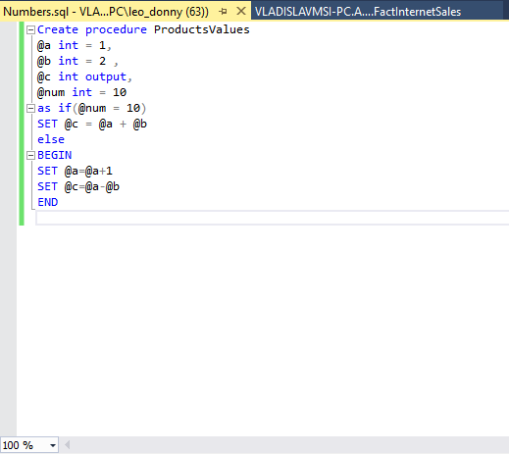

**Assignments**

1. Create a stored procedure that displays how many years have passed since 2000. Display the number of leap years after 1000. Select a table in your database that has a column with numeric values. Display all rows where the values ​​in the columns are less than or equal to the input parameter.
2. Create a stored procedure that calculates the arithmetic mean of 5 numbers. Show how many centuries have passed since 1500. Select a table in your database that has a column with numeric values. Display all rows where the values ​​in the columns are less than or equal to the input parameter.
3. Create a stored procedure that calculates the geometric mean of 6 numbers. Find out if the input date is winter, spring, summer, or autumn. Use the following command: SET DATEFORMAT. The date format options have the following meanings: mdy, dmy, ymd, myd, and dym (m, d, and y are day, month, and year, respectively). Select a table in your database that has a column with numeric values. Display all rows where values ​​are between two inputs.
4. Create a stored procedure that displays your first name, last name, and age. Write a stored procedure that will show what day of the week it is today. Select a table in your database that has a column with numeric values. Display all rows where values ​​are between two inputs.
5. Create a stored procedure that compares three numbers and shows the largest, smallest, and average. You have 4 input parameters and you need to find the value of the expression F=a*4-6*b+7*c. Select a table in your database that has a column with numeric values. Display all rows where all values ​​are greater than the three inputs.
6. Create a stored procedure that finds the longest string from 3 inputs. You have 3 input parameters and you need to find the value of the expression F=2*a-5*c+2*d. Select a table in your database that has a column with numeric values. Display all rows where all values ​​are greater than the four inputs.
7. Create a stored procedure that finds the shortest string from 3 inputs. You have 4 input parameters and you need to find the value of the expression F=5*b-4*a*b-3*c-12*b. Select a table in your database that has a column with numeric values. Display all rows where all values ​​are between two inputs.